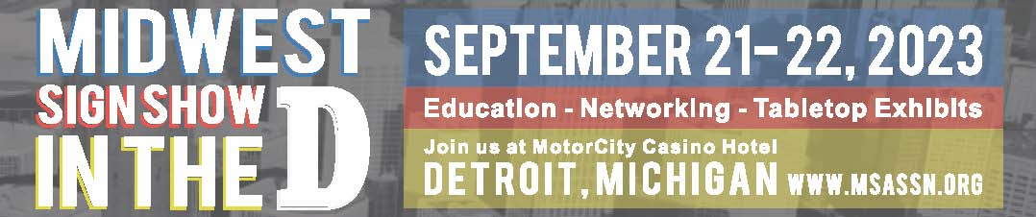
Registration Form (Complete one form per person. More event info: www.msassn.org)

Contact Information:

Name_____________________Title_______________________Company________________________

Street______________________________City_______________________ST______Zip_____________

Phone______________________________Email_____________________________________________
Please check here if you require special services _____

Registration Information: Schedule of Events:
Tabletop Exhibit Hall Admission $10 ________ Thursday, September 21
Happy Hour in Exhibit Hall Free* ________ 4:00-7:30 pm - Exhibit Hall Open
Morning Refreshments Free* ________ 6:00-7:30 pm – Happy Hour in Exhibit Hall
Seminar-Skills School for Friday, September 22
Professional Development $20 _________ 8:30 am-2:30 pm – Exhibit Hall Open
Afternoon Refreshments Free* _________ 8:30-9:30 am – Morning Refreshments in
Seminar-Tactical “To-Do” List: Make Exhibit Hall
Your Professional Life Work $20 __________ 10:00-11:00 am – Seminar-Skills School for
*Free events require registration; space is limited. Professional Development
Total: $________ 12:00-1:00 pm – Afternoon Refreshments in
Exhibit Hall
2:30-3:30 pm – Seminar-Tactical “To-Do” List:
Make Your Professional Life Work
How to Register:
EMAIL: DeeMSA@cinci.rr.com; MAIL: MSA, 4128 Woodsly Dr., Batavia OH 45103;
QUESTIONS: MSA, 513-753-8664

Payment Information (payable to MSA in US dollars only):
Credit Card Number______________________________________
CSV________ Expiration date___________ Amount authorized $________________________________
Name (as it appears on card)_________________________ Zip code card billed to__________________
Signature_________________________________________ Date________________________________

