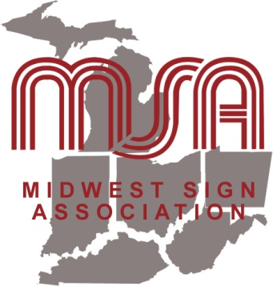
Midwest Sign Association
2024 Summer Meeting
Sawmill Creek Resort
Huron, Ohio
June 13-14, 2024

Registration Form
Please print!

Company Name: ______________________________________________________________________

City: _______________________________ State: ______ Telephone: ___________________________

Email: __________________________________________

Pre-registration prices apply until May 28. Please enter name(s) and CIRCLE the appropriate fee(s):

Names | June 13-14  All events  (does not include golf) | June 13  Golf | June 13  Reception & Banquet  Only | June 14  Breakfast & MSA Meeting Only | June 14  Seminars & Working Lunch Only
____________________________ | $326 | $110 | $114 | $32 | $197
____________________________ | $326 | $110 | $114 | $32 | $197
____________________________ | $326 | $110 | $114 | $32 | $197
____________________________ | $326 | $110 | $114 | $32 | $197
Meeting Sponsorships:  ___________________________ | Sapphire  $1,299 | Diamond  $824 | Emerald  $499 | Ruby  $299
Total enclosed: $ _____________

Make checks payable to: MSA, 4128 Woodsly Dr., Batavia, OH 45103

In case of medical emergency, contact: ____________________________________________

Phone Number(s): _____________________________________________________________

Questions, dietary restrictions or special needs? Call 513-753-8664 or email DeeMSA@cinci.rr.com

